**GESTURE CONTROLLED CAR**

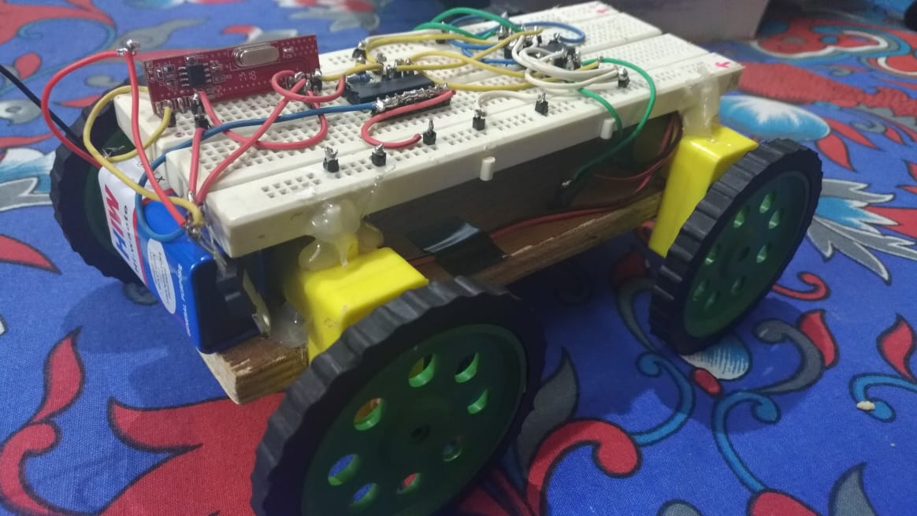

**Material Required**

1. Arduino UNO ATMEGA328
2. RF module
3. Decoder(HT12D) and Encoder(HT12E) ICs
4. Motor Driver(L293D)
5. DC Motors
6. Batteries
7. Wires

**Working**

Gesture means action or posture that is conveying a message. A Gesture Controlled car is a kind of car which can be controlled by hand gestures. The user just needs to wear a small device on his hand which consist of accelerometer, encoder and transmitting device . Movement of the hand in a specific direction will transmit a command to the arduino, a microcontroller which will then send specific signal accordingly. Encoder IC is used to encode the four bit data and then it will be transmitted by an RF Transmitter module. At the receiving end an RF Receiver module will receive the encoded data and decode it by using a decoder IC. This data is then passed onto a motor driver to rotate the motors in a special configuration to make car move in the same direction that is defined for that specific gesture of the hand.

**Submitted By-**  Abhijeet(02), Ashish(14), Keshav(33) and Monarch(38)